**Node Localization in Wireless Sensors Network**

A project report submitted in the partial fulfilment of the requirements for the award of degree of

**Bachelor of Technology**

in

**Computer Science and Engineering**

Submitted

*by*

**Reymond Jones Kharshandi Sunil Aglasow**

**D/17/CS/107 D/19/CS/207**

under the guidance of

**Mr. Ajit Kr. Singh Yadav**

**Assistant Professor**



**DEPARTMENT OF COMPUTER SCIENCE & ENGINEERING**

**NORTH EASTERN REGIONAL INSTITUTE OF SCIENCE AND TECHNOLOGY**

(DEEMED TO BE UNIVERSITY)

UNDER MINISTRY OF EDUCATION, GOVT. OF INDIA

NIRJULI-791109, ARUNACHAL PRADESH, INDIA

June, 2022



**CERTIFICATE**

This is to certify the project report entitled, **“Node Localization in Wireless Sensor Networks”**, submitted in partial fulfilment of the requirements for the award of Degree Certificate of Bachelor of Technology in Computer Science Engineering to the **North Eastern Regional Institute of Science and Technology**, Nirjuli, Arunachal Pradesh-791109, is a record of Bonafide academic work carried out by **Mr.Reymond Jones Kharshandi** (D/17/CS/107)and  **Sunil Aglasow** (D/19/CS/207).

Under our guidance and supervision, the results embedded in the project work have not been submitted to any other University or Institute for the award of any Diploma or Degree.

**Mr. Ajit Kr. Singh Yadav**

(Project Guide)

**Mr.** **Ashwini Kumar Patra Dr. Moirangthem Marjit Singh**

(Project Co-ordinator) (Head of Department)



# 

# DECLARATION

We hereby declare that the project **“Node Localization in wireless Sensor Network”** submitted to the North Eastern Regional Institute of Science and Technology, Nirjuli, is a record of an actual work done by under the supervision of Mr. Ajit Kr. Singh Yadav, Assistant professor Department of Computer Science and Engineering, NERIST. The project report is being submitted in order to complete the prerequisites for the degree of “Bachelor of Technology” in Computer Science and Engineering. This report’s findings have not been submitted to any other university or institute for the purpose of conferring a degree or diploma. The greatest care has been made to guarantee that any content used in the development of the project, such as codes, libraries, references, and so on, does not infringe on any rights and is not plagiarized to the greatest extent possible. In addition, correct attribution has been given in the form of citations whenever and wherever possible.

|  |  |
| --- | --- |
| Reymond Jones Kharshandi | Sunil Aglasow |
|  |  |
| (D/17/CS/107) | (D/19/CS/207) |

# Acknowledgement

This project report on **“Node Localization in wireless Sensor Network”** brings us great delight and a sense of accomplishment. We’d want to use this occasion to extend our heartfelt gratitude to everyone who has assisted us in completing this project successfully. We’d like to use this occasion to express our heartfelt gratitude to our internal guide, Mr. Ajit Kr. Singh Yadav, for his helpful advice and for sharing his extensive expertise and experience in project preparation with us. We would want to express our gratitude for his time and for correcting our errors in order to improve the accuracy of our project. We would also want to express our gratitude to the entire faculty of Computer Science and Engineering, particularly for their constant guidance. We are delighted to extend our heartfelt gratitude to every one of our Department of Computer Science and Engineering faculty members. Last but not least, we’d want to express our gratitude to all of our classmates and professors from the Department of Computer Science and Engineering for sharing their expertise on the subject and assisting us in making this a better project.

# Abstract

We offer a hub restriction in WSNs in this examination. As indicated by the recommended approach, every normal hub or area mindful hub appraises its distances just to secures that are reliable or position-mindful hubs that are position-mindful.

The last option are appropriately chosen utilizing another reliable anchor determination approach, which guarantees right distance estimation and subsequently works on the accuracy of our restriction technique. Indeed, simulations show that in terms of accuracy, it exceeds the best existing range-free localization algorithms.

The latter are process the main using a novel, dependable anchor selection approach, which ensures correct distance measurement and so improves the precision of our localization method. Indeed, simulations show that in terms of accuracy, it exceeds the commonly used range-free localization algorithms.

**List of figures**

|  |  |  |
| --- | --- | --- |
| Figure No | Figure Name | Page no |
| 1.1 | WSN Architecture | 2 |
| 1.2 | Application of WSN | 2 |
| 1.3 | Motivation scenario | 4 |
| 1.4 | Centralized strategy | 5 |
| 1.5 | Distributed strategy | 6 |
| 1.6 | Grid networking technique | 7 |
| 1.7 | Direct communication | 8 |
| 2.1 | Architecture for Ees-Mhrt | 12 |
| 2.2 | System model | 14 |
| 2.3 | Classification of routing protocols in WSN | 15 |
| 4.1 | Classification of localization algorithms | 17 |
| 4.2 | Network topology | 22 |
| 4.3 | Reliable anchors | 24 |
| 4.4 | Distance Anaylis | 26 |
| 5.1 | Constant anchor with varying mobile | 29 |
| 5.2 | Constant mobile with varying anchor | 30 |
| 5.3 | Error measurement by localization NRMSE | 31 |

# Contents

|  |  |  |
| --- | --- | --- |
| Sr No. | Topic | Page number |
|  | **Declaration** |  |
|  | **Acknowledgment** |  |
|  | **Abstract** |  |
|  | **List of figures** |  |
| 1 | **Introduction**   * 1. Wireless Sensor Network Architecture   2. Application of WSNs   3. Habitat and Environmental Monitoring for Scientific Application   1.3.1 Health monitoring  1.3.2 Tracking applications  1.3.3 Intelligent home environment  1.3.4 Localization applications   * 1. Project approach   2. WSNs Approaches and Techniques      1. Centralized strategy      2. Distributed Strategy      3. Grid networking technique      4. Cluster-Based Formation      5. Clustering parameters      6. Protocols in WSNs   3. Wireless Sensor Networks: Benefits and Drawbacks   1.6.1Advantages and Drawbacks in a Distributed Method | 1-10 |
| 2 | **Literature Survey**  2.1 Cooperative Transmission in Wireless Sensor Networks for  Energy Hole Mitigation  2.2 Development of a More Efficient Secured Multi Hop Routing  Technique for Wireless Sensor Networks  2.3 Balancing Energy Consumption in Data-Collecting Sensor Net-  works to Increase Network Lifetime  2.4 In Wireless Sensor Networks, Balanced Clustering for Energy  Efficient Routing | 11-15 |
| 3 | **Objectives** | 16 |
| 4 | **Problem Statement and Methodology**  4.1 Localization of the source or the target  4.1.1 In a wireless sensor network, single-target or source  localization is used  4.1.2 Localization of Multiple Targets in Wireless Senso Networks  4.1.3 Localization of a single target or source in a wireless binary sensor networks  4.2 Node Self-Localization  4.2.1 Localization with a Range  4.2.2 Range-Free Localization  4.3 This paper investigates the DV-Hop Localization Algorithm  4.3.1 The DV-Hop Algorithm’s Basic Procedure  4.3.2 Blunder Analysis of the DV-Hop Algorithm  4.4 Strategy for Choosing Reliable Anchors  4.5 Algorithm used  4.6Distance Estimation Technique | 17-26 |
| 5 | **Simulation and Analysis of the Results**  5.1 Creating an Environment for Network Simulation 5.2Simulation and Analysis of Performance  5.3 Simulation and testing parameter | 27-31 |
| 6 | **Conclusion and Future Work**  6.1 Conclusion  6.2 Future work | 32 |
| 7 | **Reference** | 33-34 |

# Chapter 1

# Introduction

Remote sensor organizations (WSNs) are a moderately new kind of remote organization that is quickly building up some momentum in both business and military applications. A remote sensor network is an assortment of disseminated, independent sensor gadgets that track physical or ecological factors. Remote sensor organizations (WSNs) comprise of minimal expense, low-correspondence sensors.. Physical phenomena such as light, temperature, and pressure are collected by the nodes at random. A sensor node cannot communicate directly with a remote access point (AP) due to their short transmission range. Therefore, they use multi-hop communication via a series of intermediary nodes, each relaying data to the AP in turn[5]. Instances of regular applications incorporate climate and woods observing, war zone observation, actual checking of natural components like tension, contamination, temperature, and vibration, and following human and creature development in woodlands and boundaries.

## 1.1 Wireless Sensor Network Architecture

By and large, a WSN has insignificant or no framework. It is comprised of an enormous number of sensor hubs (from two or three tens to thousands) that work across the climate. The two sorts of WSNs are unstructured and structured, which are used to monitor a region and collect data. A WSN that has a large number of sensor nodes is called an unstructured WSN. An organized organization enjoys the benefit of permitting less hubs to be introduced while likewise bringing down network upkeep and the executives costs. Since hubs are currently situated at specific areas to give inclusion, less hubs can be sent, while impromptu organization can leave regions uncovered[8]. Sensor center points are much of the time scattered all around a sensor field, as displayed in Figure 1.1. Every single one of these scattered sensor centers is fit for social occasion information and transferring it to the sink and end clients. Here, A multi bounce framework that has less construction modelling via the sink, as shown in Figure1.1, directs information back to the end client. The sink might correlate via Web or Satellite, with the errand chief hub. This sensor hub called WINS is constructed in which the sensor hubs, controls, and processors are provided a conveyed system and Web access. Since there are so many sensor center points, the WINS frameworks exploit the brief distance between them to give multi-skip correspondence and lessen power utilization. In the WINS frameworks, the course by which data is directed back to the not set in stone by the underlying designing displayed in Figure1.1. The WINS hub, which is a sensor hub, captures natural information, which is then steered via the WINS hubs, bounce by bounce, until it reaches the sink, which is a WINS portal. As indicated by the building design, the sensor hubs A, B, C, D, and E are the WINS hub. The passage of WINS communicates with the client via standard system administrations, such as the Web. Some of the challenges faced by wireless sensor networks are :

(i) Scalability (ii) Heterogeneity (iii) Systematic design (iv) Privacy and security (v) Energy efficiency (vi) Responsiveness (vii) Robustness (viii) Self-configuration and (ix) Adaptation.

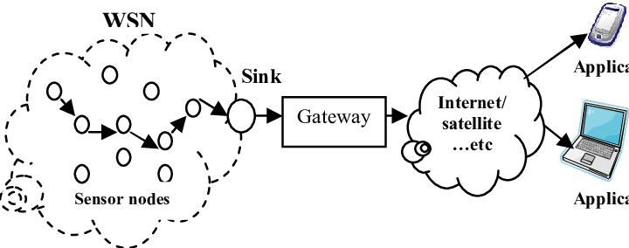

Figure 1.1: WSN Architecture

## 1.2 Application of WSNs

WSNs benefit from developments in computing technology, which have resulted in the development of compact, powered by battery, smart wireless sensor nodes. The following nodes are active computer and communication devices that can not only be an example of real-world events but also can filter as well as share, integrate, and perform operations on the collected data.

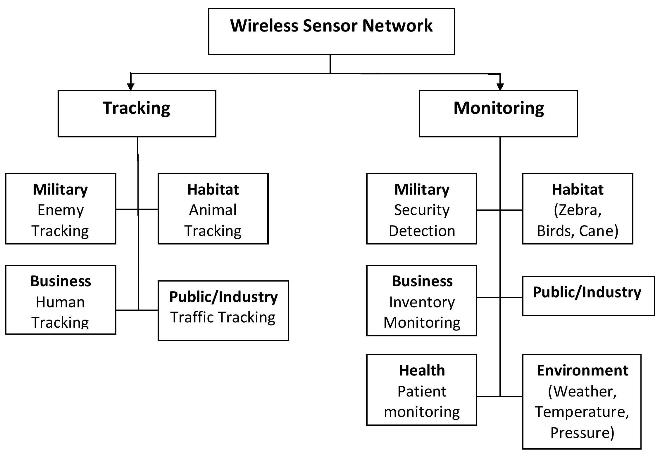

**Figure 1.2:** Applications of WSN

## 1.3 Habitat and Environmental Monitoring for Scientific Applications

Detection of Forest fire and flood, as well as precision agriculture are all examples of precision agriculture. Alarms transmitted over the WSN through multihop allow for a timely response before the fire becomes unmanageable.

**1.3.1 Health monitoring:**

The WSN can also be used as part of a wearable system for health monitoring for patients. The Harvard University-developed CodeBlue system employs a WSN to issue an alert when vital indicators deviate from normal. The system goes on to monitor the heart rate, EKG data and oxygen saturation. It then distributes it across wireless network that is short-ranged to different types of devices, which includes ambulance-based terminals.

**1.3.2 Tracking applications:**

Sensor nodes are used to detect existence of people and things rather than ambient data. Objects can be detected in the simplest scenario by indexing them with a tiny sensor node. The sensor node’s motion across a field of sensor nodes placed in known places throughout the surrounding is tracked. Adding to it, The sensor nodes are also being used as active tags that alert other devices to their presence.

**1.3.3 Intelligent home environment:**

Sensors allow the smart home to engage with the environment, and actuators allow the smart home to interact on the context.

**1.3.4 Localization applications**

Armed forces and local police organisations face a difficult task in detecting and finding snipers. The majority of successful sniper detection systems rely on a WSN that measures acoustic events due to a shot, including the terminal blast’s spherical wave (moving at the speed of sound) and the shock wave formed by the flying projectile. It is feasible to establish the location of the sniper and the trajectory of the bullet by using the sensor nodes’ readings of acoustic phenomena.

## 1.4 Project approach

Various procedures to concentrating on the confinement issue in sensor organizations could be envisioned. The endlessly range free arrangements are the principal divisions.The proposal will give an investigation of the most widely recognized sensor network territory systems, like the utilization of gotten signal power or season of appearance, as well as a few performing calculations in view of them.

Let, *Na* and *Nu* = *N* − *Na*, lets have (*xi,yi*) *i* = 1*,...,Na* and (*xi,yi*) , *i* = *Na* + 1*,...,N* whose of the common people We propose an effective anchor-based localisation approach in the following section, with the goal of properly estimating the regular node placements. However, in such networks, the shortest pathways are extremely likely to be not linear due to the presence of an obstruction, as can be seen from the diagram Figure1.3. Unfortunately, when mapping the path length into distance, this results in an overgeneralization, reducing localization accuracy. Figure1.3 shows one illustration of this, the *Nh* = 6 hops. Because node 1 has to know its distances from all anchors in the site in order to locate itself, it calculates its distances to *A*1 as follows:

*de* = *Nh* × *h*¯*s* (1.1)

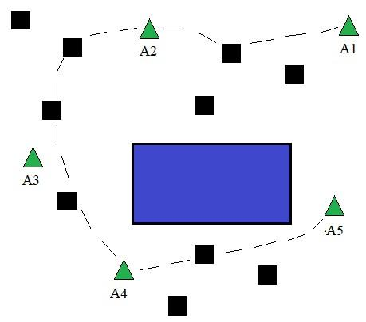

Figure 1.3: Motivation scenario

The intriguing way for avoid this problem are appropriately choose the writers such scenarios like the one depicted in Figure1.3 is neglect. The chosen nodes will be referred to as reliable anchors from now on. In the following sections, we build our innovative localization method using this trusted anchor selection technique.

## 1.5 WSNs Approaches and Techniques

WSNs are comprised of a set number of sensor gadgets that are geologically spread in a specific indoor or outside area (typically predefined). A's WSN will likely gather natural information, and the area of hub gadgets might be perceived or obscure deduced. With all gadgets, information parcels can have genuine or reasonable correspondence; this correspondence characterizes a geography in view of the application. For instance, a WSN could have similar geographies for the two kinds of geographies (network, star, star, transport and so on).

**1.5.1 Centralized strategy**

For networks where the handling power limit is generally founded on a solitary gadget, incorporated development strategies are fitting. This gadget is accountable for the handling, coordination, and the board of the detected data exercises in such examples. It likewise sends this data to a sink node (Figure1.4). The principal benefits of this approaches are as per the following:

1. High energy is possible with centralised solutions.
2. Within the network, roaming is permitted.iii. The examination of network coverage has been simplified.
3. The availability of context information makes for better application design.

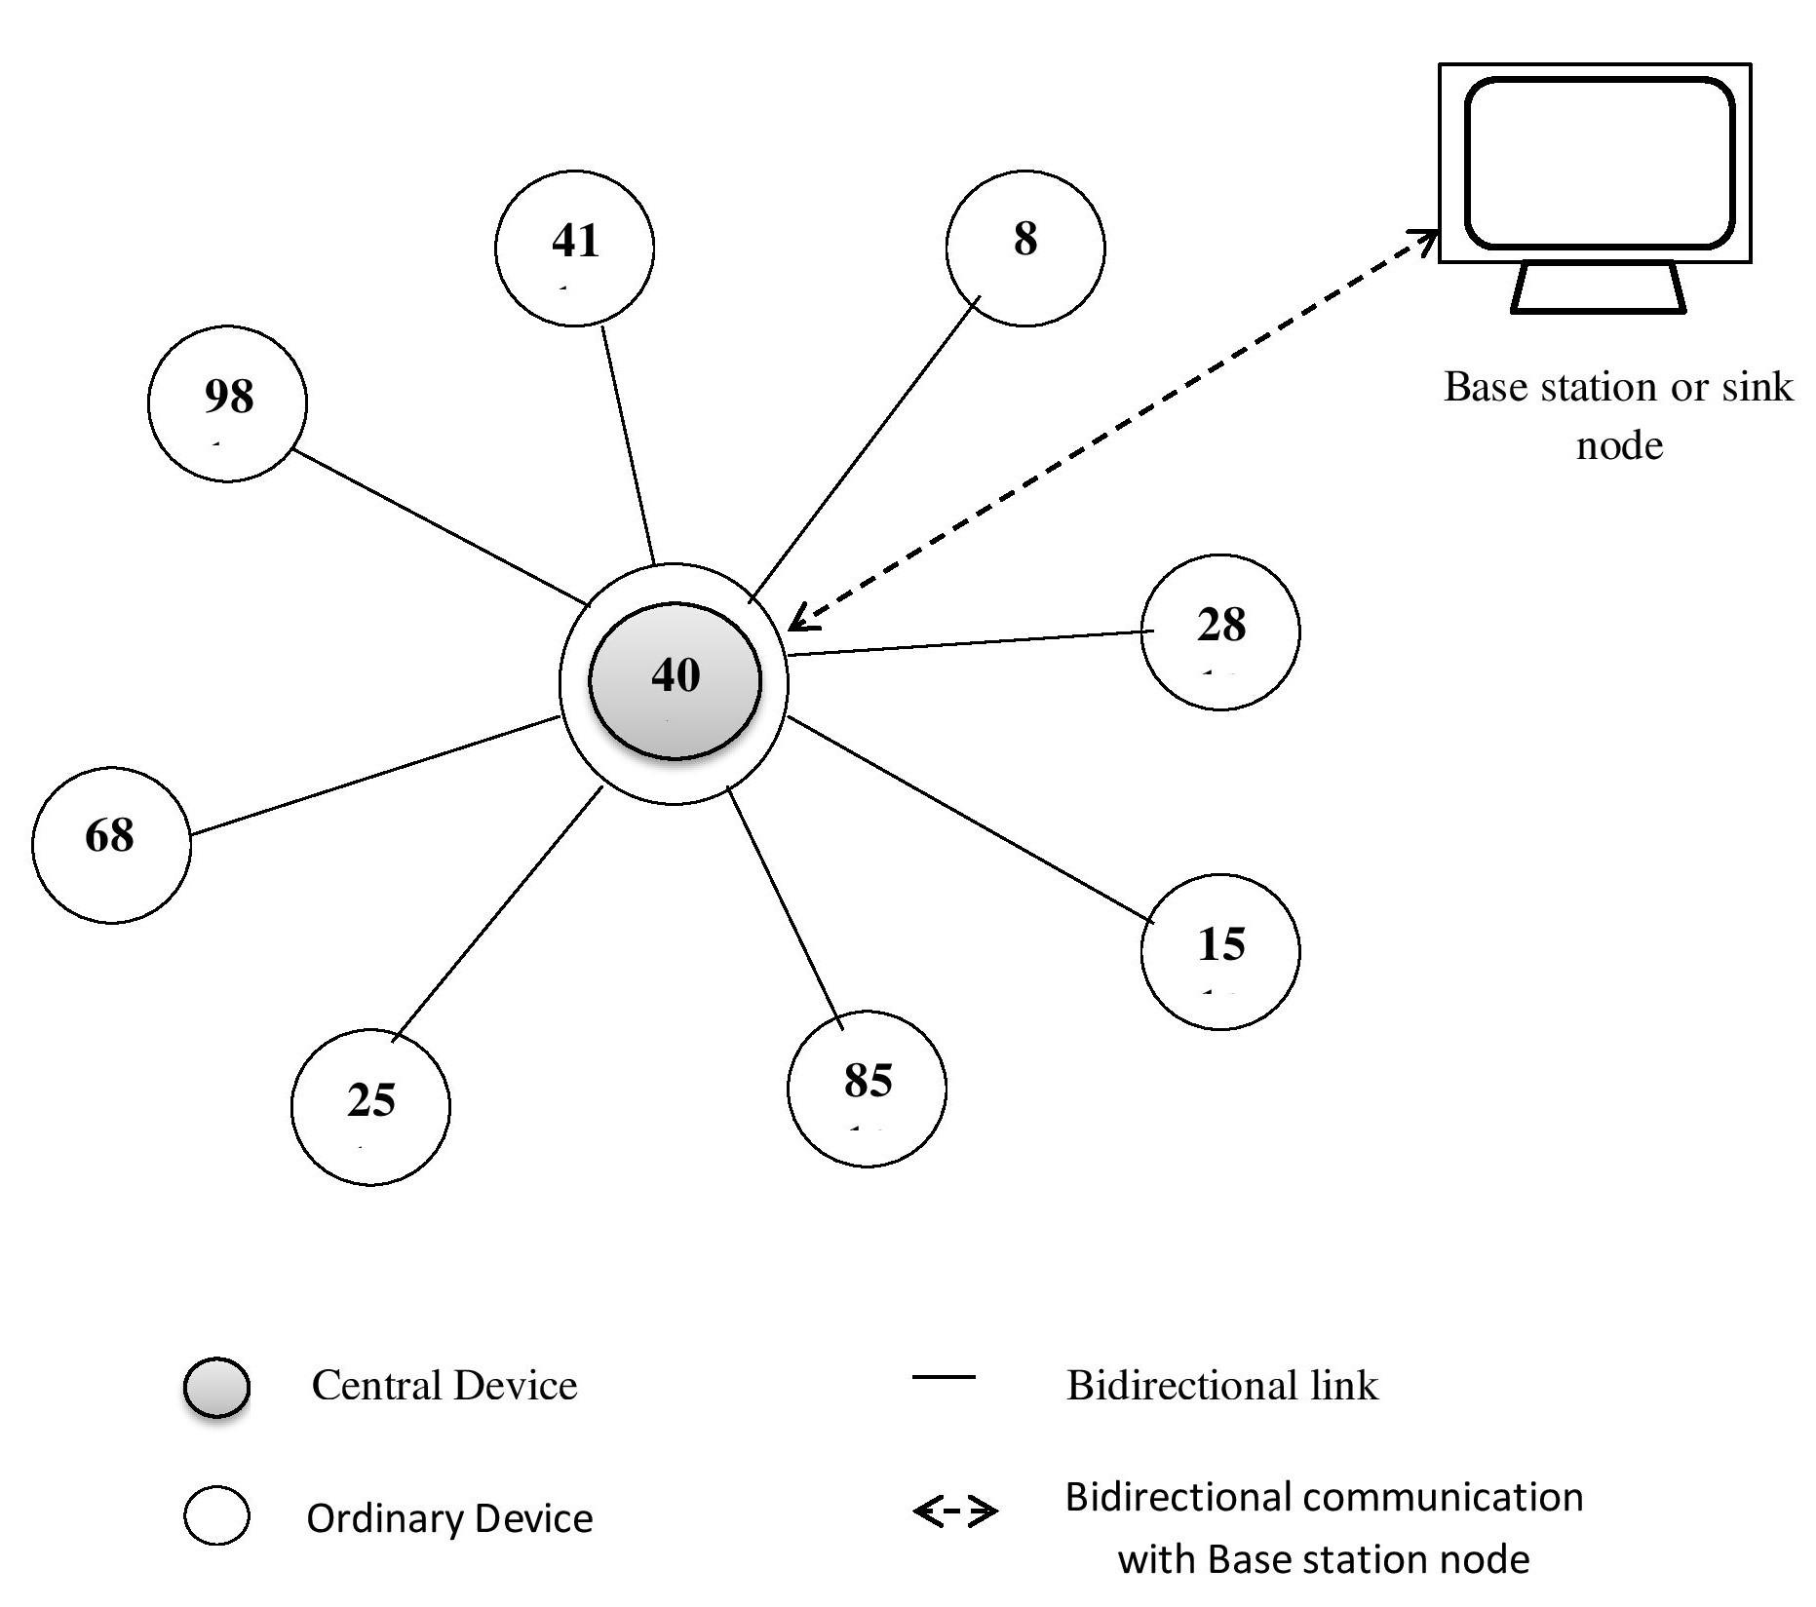

Figure 1.4: Centralized strategy

**1.5.2 Distributed Strategy**

In circulated arrangement draws near, every hub deals with its own data, which is restricted to its nearby environmental factors (single-jump neighbors). Coming up next are the principal properties of dispersed networks:

1. There are self-contained gadgets.
2. Some anchor communicates with the nodes in its immediate vicinity.
3. Other interconnection devices aren’t really re-quired.
4. Their adaptability enables them to target tough areas.

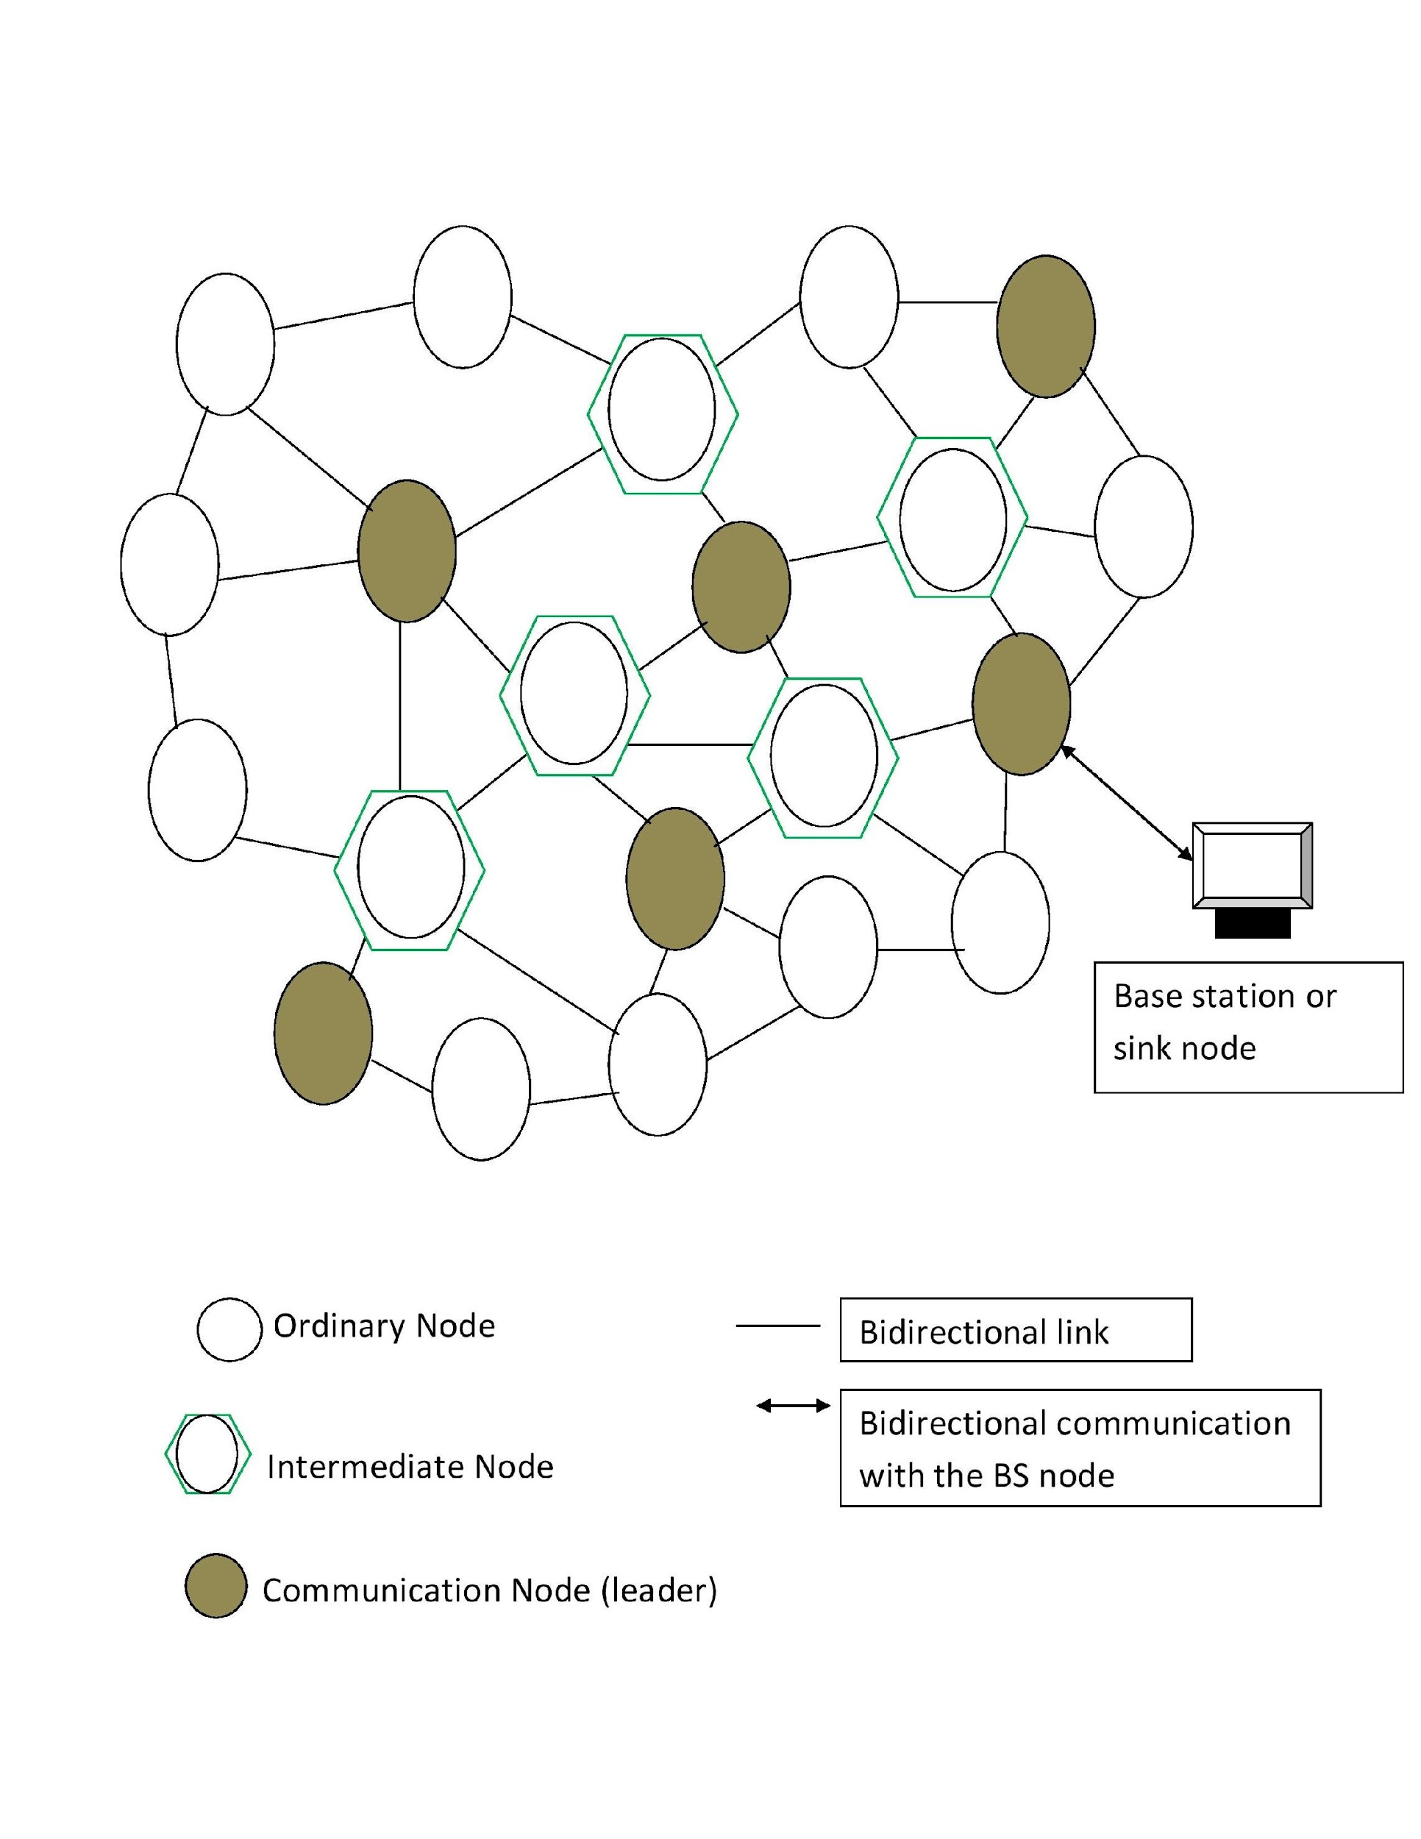

Figure 1.5: Distributed strategy

Self-association is currently quite possibly of the most fundamental dispersed technique lately. This technique permits a sensor organization to deliver developing conduct in which hubs impart and facilitate independently.(Figure 1.5). The objective is to do exercises that are past the single hub's capacities. Nature gives instances of these techniques (bug provinces, organic cells, the herd of birds, the rummaging conduct of insects, and so forth.)

**1.5.3 Grid networking technique**

For energy protection, the Geographical Adaptive Fidelity (GAF) convention is utilized. The organization is separated into networks by means of this convention. Figure1.6; Each hub has direct correspondence with simply one more sets of hubs. The hub responsible for checking whether there is an occasion in the framework is alluded to as the Grid Head hub and Ordinary hubs are different hubs, and they awaken consistently.

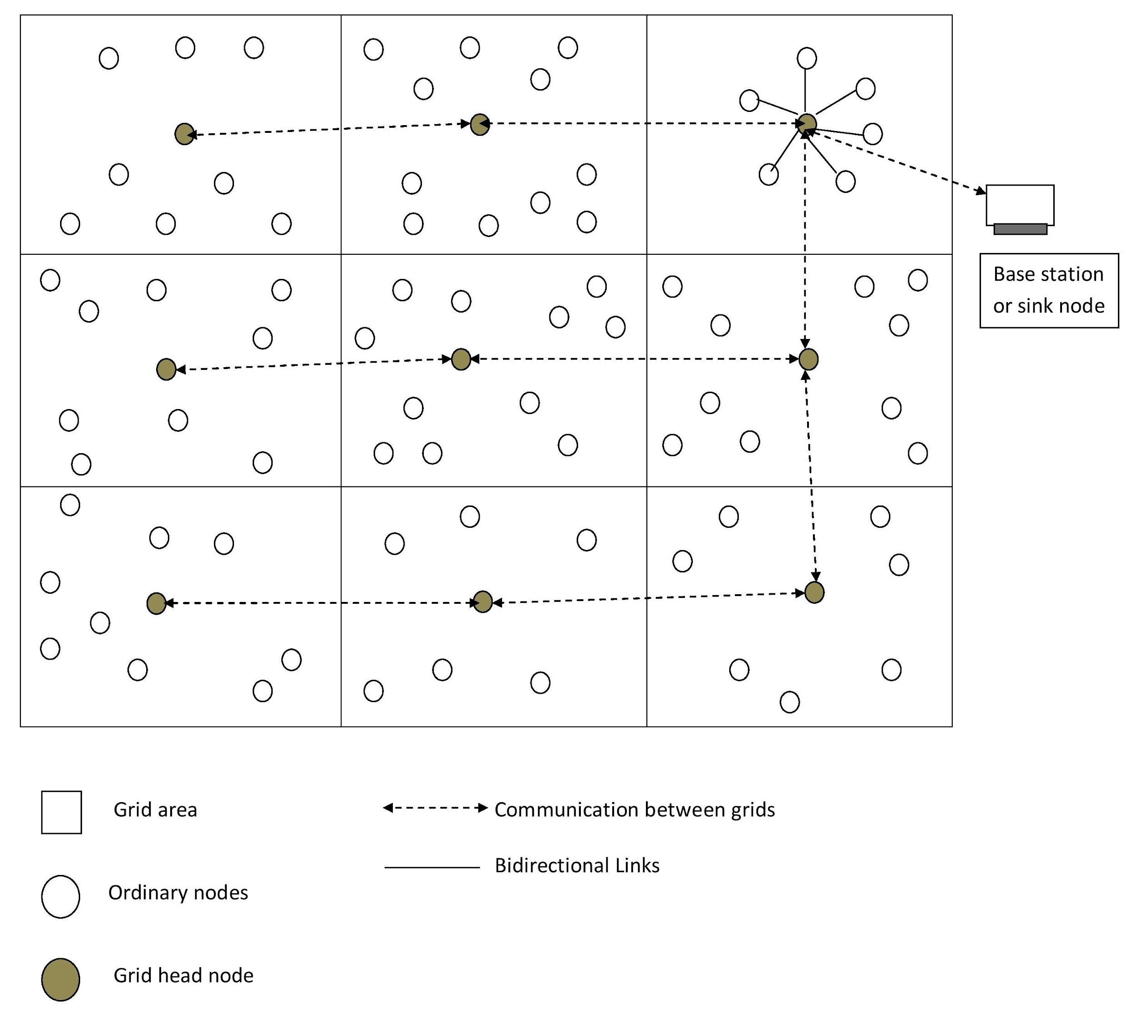

Figure 1.6: Grid networking technique

**1.5.4 Cluster-Based Formation**

Direct contact of sensor nodes with BS or multihop communications of sensor nodes towards BS is not viable in WSN due to limited resources, as energy consumption is significant, resulting in sensor node expiration early, as illustrated in Figure1.7. Because WSN cannot handle long-haul communication, direct or single-tier communication is not possible for large-scale networks. Direct connection has a number of drawbacks, including high energy consumption, data duplication (sensing nodes near to each other reporting data with very little variations), and the distant nodes dying soon. To solve these issues, a two-tier communication system based on a hierarchical approach with nodes divided into clusters is adopted. The leader node, also known as the cluster head (CH), and is in charge of gathering data and transmitting it to the BS.

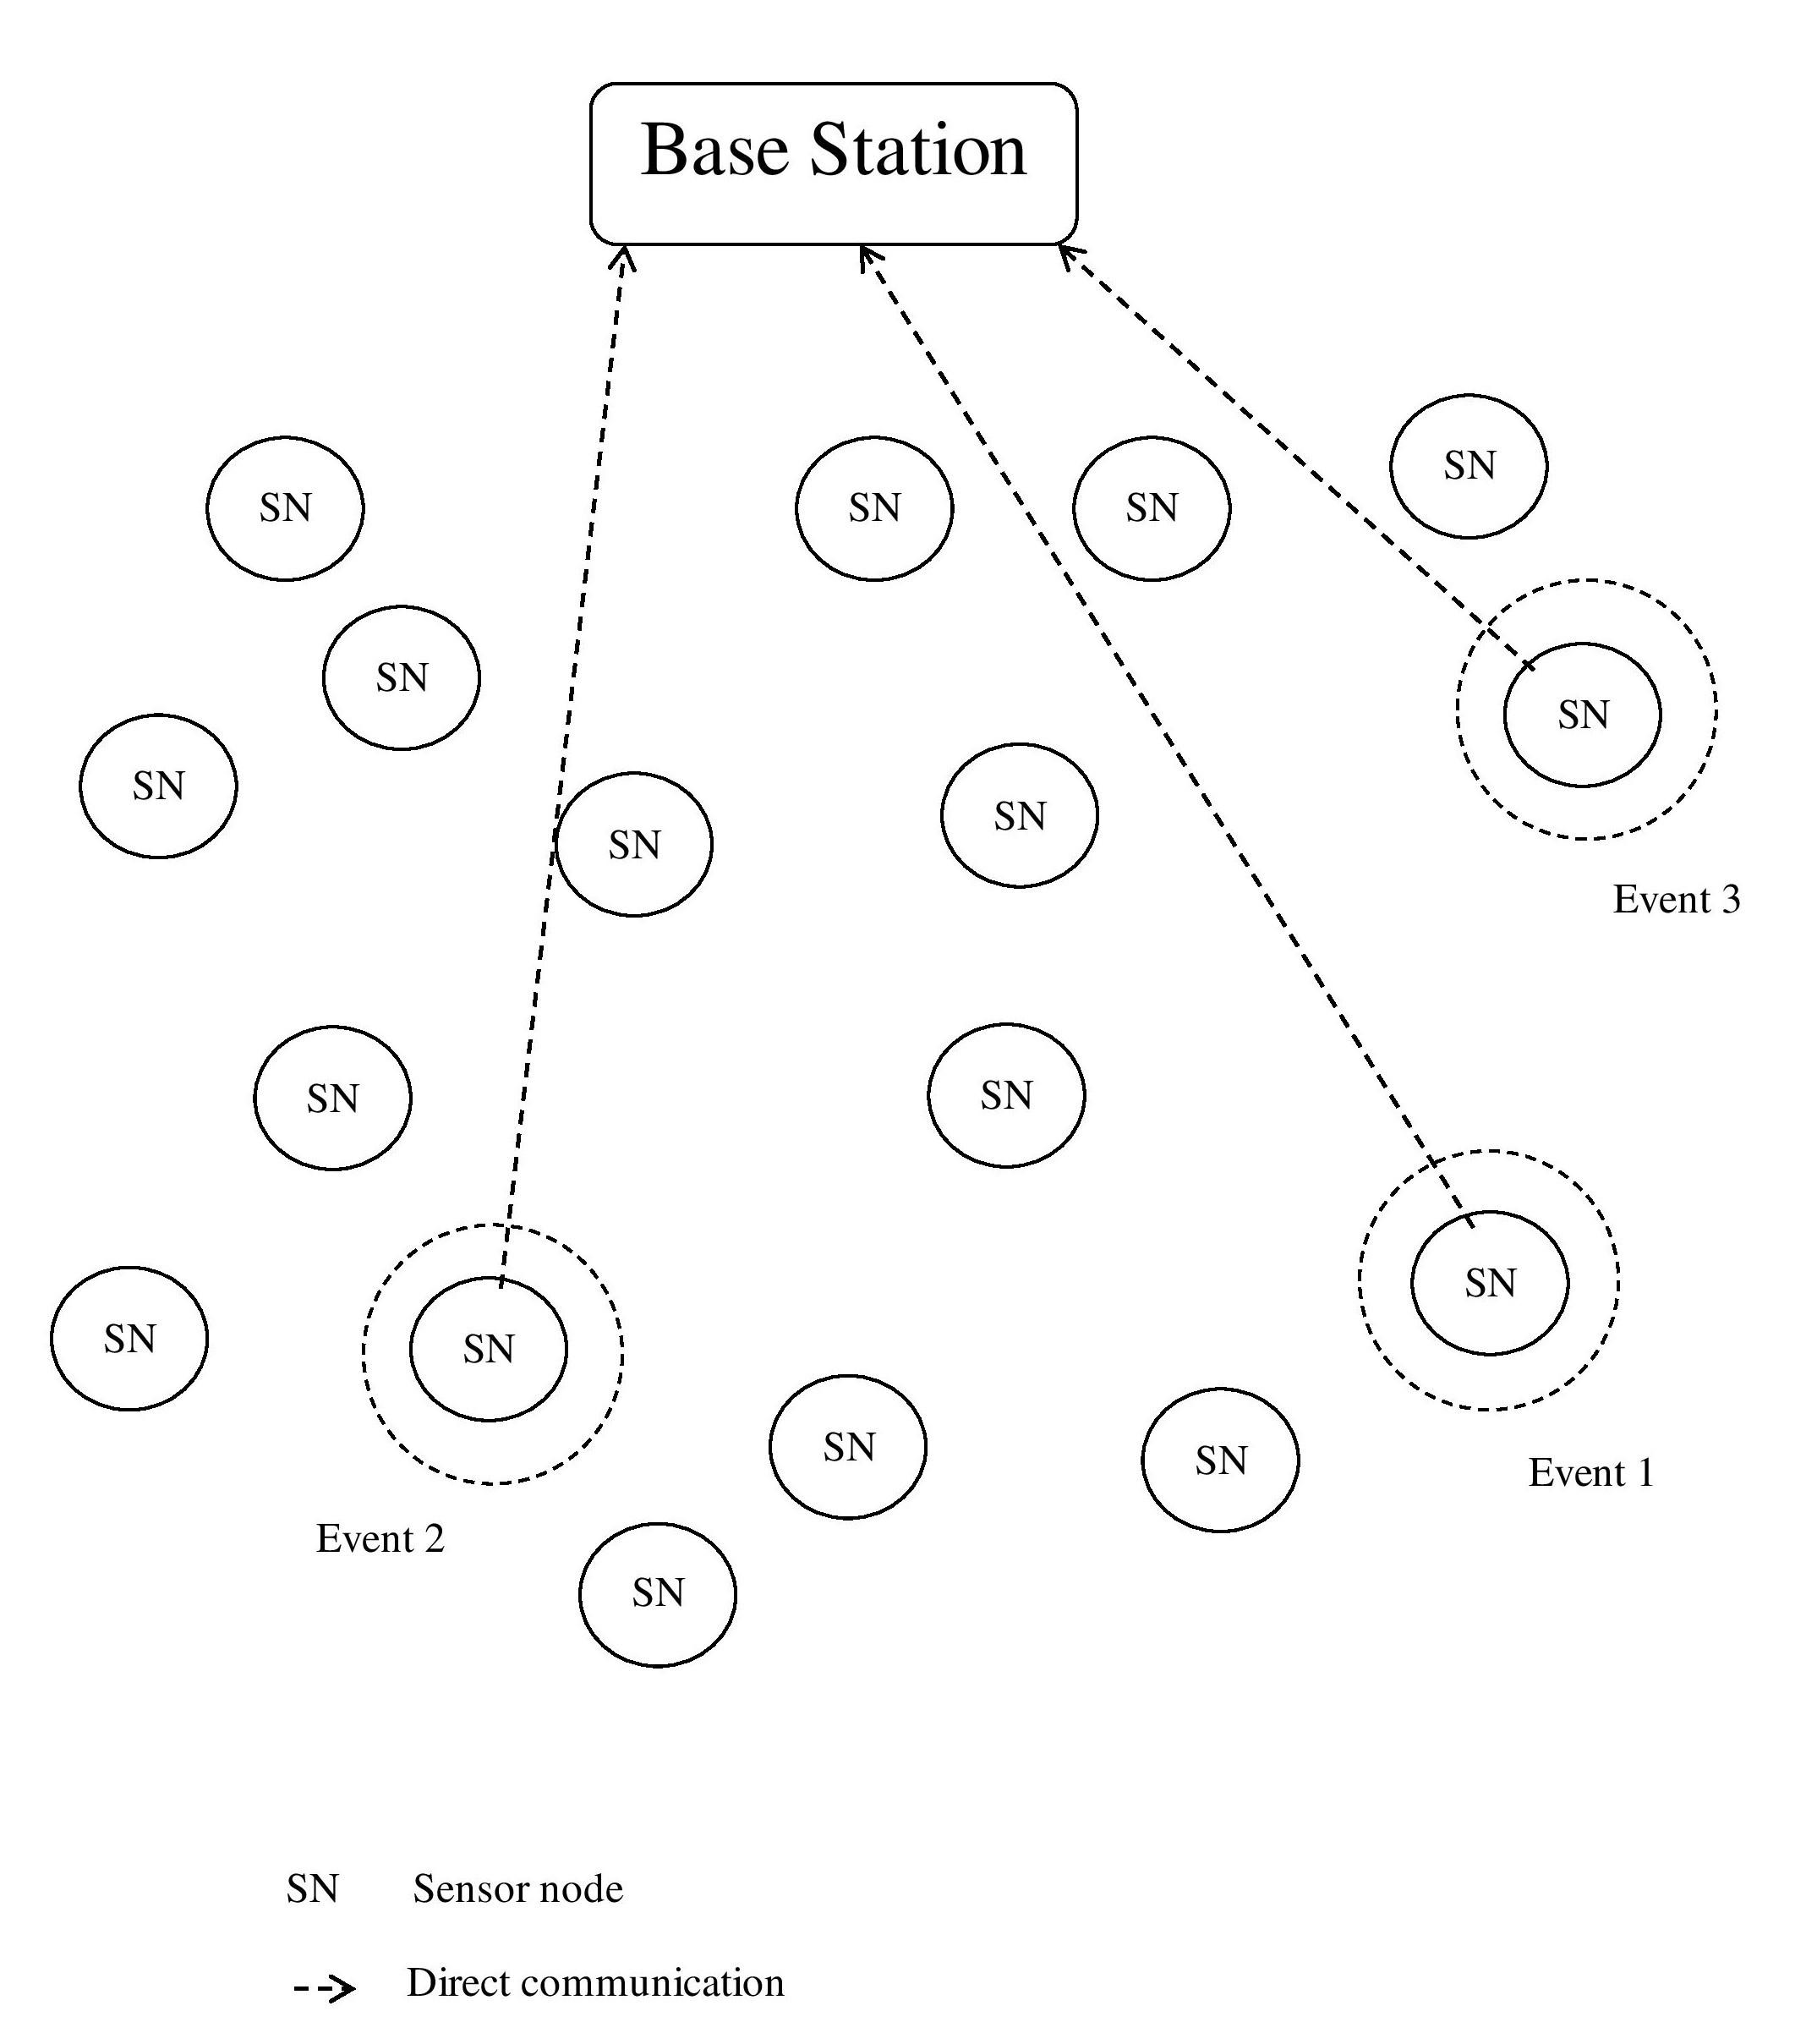

Figure 1.7: Direct communication

**1.5.5 Clustering parameters**

The clustering parameters that could affect the clustering process directly or indirectly are mentioned below.

**Cluster Count:**

Group head determination and parts and information in most realized frameworks bring about a fluctuated bunch count, where the quantity of bunches is foreordained. It's a pivotal boundary for grouping strategy execution, and it vacillates with network size.

**Cluster Formation:**

Cluster formation can be centralised, in which case the decision is made by BS, or dispersed, in which case clusters are established without any coordination. Hybrid techniques are also being employed in the literature, where the benefits of both approaches are combined.

**Intracluster Communication:**

Within a cluster, it refers to the communication of sensors with their elected CH. Sensor nodes connect with CH directly (one-hop) in most techniques, depending on the distance between node and CH. Multicast communication can also be used for intracluster communication in big networks.

**Mobility:** The sensor hubs and group heads are both static in a static organization, bringing about stable bunches. Furthermore, node static positions facilitate network (intracluster and intercluster) control. If the nodes change their positions, the cluster and CH evolve over time, necessitating ongoing management.

**Node Types:**

Some of the previously proposed approaches have used uneven nodes in a network, while others have employed homogeneous nodes. CHs are often endowed with more communication and processing resources than conventional nodes in a heterogeneous environment. In a homogenous network, all nodes have the same skills, and only a few are designated as CHs using efficient approaches.

**Algorithm Complexity:**

Another key factor in clustering is method complexity; newer methods attempt for rapid cluster creation and CH selection. The temporal complexity or converge is kept constant in most systems, while it varies depending on the set of network nodes within the network in others.

**1.5.6 Protocols in WSNs**

The protocols are divided into layers and sublayers, allowing you to control how and when data is collected, transmitted, routed, and processed on any device. Prior to communicating the information to another detecting gadget, the information interface layer gets and processes it. This layer is accountable for information transmission and, at times, mistake amendment. The two dynamic climate are Logical Link Control (LLC) and Media Access Control(MAC).

LLC It fills in as a connection point between the MAC layer and systems administration exercises, introducing and mistake control, as well as information transmission among gadgets on an organization.

Macintosh Access control is set by the sublayer, which likewise handles bundle transmission, information outline approval, transmission mistake checks, information rates, stream control, message affirmations, etc. This sublayer straightforwardly affects how the hub cooperates with the environmental factors to gather extra course data.

These conventions, as opposed to opened conventions, are switched off constantly and just turned on at characterized timeframes, checking for action in the channel; in the event that action is found, they start gathering information; in any case, they switch off for energy protection. The channel energy level or the transporter location might be utilized for recognition. Salud, B-MAC, WiseMAC, the ChipconCC2500 handset, and the Oakland stage are instances of these conventions.

**1.6 Wireless Sensor Networks: Benefits and Drawbacks**

Reconnaissance, observing, ecological guideline, directing, occasion discovery, multiagent frameworks, and different applications in which sensors have a critical impact are applications when remote sensor networks are especially helpful.

We've featured probably the best work in remote sensor organizations, alongside the most fundamental advantages and disadvantages of every commitment. The advantages and disadvantages of the essential concentrated and dispersed approaches are examined in this segment.

**1.6.1 Advantages and Drawbacks in a Distributed Method**

When an application must manage a large amount of data and it is desirable to have redundancy and reliability, a distributed method is frequently utilised. The advantages and disadvantages of these strategies are determined by the equipment, resources, and context.

The following are the key benefits:

The data is nearby; - i.e., a hub just keeps up with data about its nearby environmental elements (a couple of jump neighbors). Versatility is a term used to portray circulated calculations. The beset segment is reconfigured locally; on the grounds that hubs are independent, every hub settles on its own choices in view of its situation or activities. Each occupation characterizes the organization's needs and accessible data. At the point when a hub fizzles, the organization proceeds to work and execution isn't fundamentally influenced. Managing loud settings, including hindrances, is conceivable utilizing the disseminated technique. Each hub diminishes its energy utilization; regularly, directing starts whether an occasion is seen or there is an objective to follow; this implies that no energy is squandered before the strategy starts.

The quantity of jumps to a particular gadget or focus on, the quantity of retransmissions, the stream rate, the connection quality, and the quantity of gadgets are factors that could influence the exhibition of unified and circulated networks.

**1.6**

# Chapter 2

# Literature Survey

One of the most significant tactics in a wireless sensor network is localisation. Two sorts of area gauge procedures are target/source confinement and hub self-localization.. The energy-based method is most commonly used in target localization. After that, we look into node self-localization methods. Localization strategies in numerous applications have changed with the widespread adoption of the wireless sensor. In some unique instances, there are also a number of obstacles to overcome. This paper discusses nonlinear localization, node entry requirements for localization in power networks, sensor node scheduling. Finally, methods for selecting localisation in a wireless sensor network are discussed.

## 2.1 Cooperative Transmission in Wireless Sensor Networks for Energy Hole Mitigation

**Author:** Li Fei, Yi Chen, Qiang G ao, Xiao-Hong Peng, and Qiong Li, year 2015.

**Related work:** We look at two different approaches to solve the power allocation optimization challenges in the cooperative transmission strategic approach: network lifespan maximisation (NLM) and power consumption minimization (ECM). When the ideal solution does not exist, the numerical objective function is computed, and a substandard solution finding strategy is described.

**Advantages:** To acquire the spatial variety benefit, the Alamout spacetime coding and the most extreme proportion consolidating approach are utilized for helpful MISO transmission.

**Disadvantages:** These techniques don't endeavor to handle the energy opening issue, and inconsistent energy dissemination among source immediate roundabout impacts actually exists, bringing about a more limited span.

## 2.2 Development of a More Efficient Secured Multi Hop Routing Technique for Wireless Sensor Networks

**Author:** Rijin I.K, Dr.N.K.Sakthivel, Dr.S.Subasree, year 2013.

**Architecture For Ees-Mhrt:**

EES-MHRT safeguards the cross breed multi bounce directing in Wireless Sensor from aggressors misleading the mixture multi jump way by assessing the reliability of adjoining sensor hubs.It also recognises attackers based on their lack of trustworthiness and routes data through pathways that avoid those invaders in order to achieve enough throughput. ESMHRT is also highly efficient, scalable, and adjustable in terms of energy use.

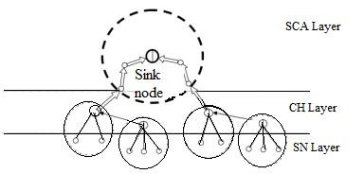

Figure 2.1: Architecture for Ees-Mhrt

1. **Sensor nodes**

Each Cluster Head and Sensor Node in a gathering conducts a survey of any remaining Cluster Heads and Sensor Nodes in a similar gathering, and every Sensor does an examination of any remaining Sensor Nodes in a similar gathering. Consistently, the ptop trust assessment is refreshed in light of either immediate or backhanded hub perceptions. Inside as far as possible, the other two hubs in the WSN will assess every sensor hub in light of direct perceptions by means of sneaking around or hearing. Every Sensor Node conveys its trust discoveries to the Cluster Head through other Sensor Nodes in a similar gathering in this present circumstance.

1. **CH layer:**

Each Base Station evaluates the dependability of the Sensor Nodes in their bunch. Besides, each Cluster Head conveys its trust execution worth to any remaining Cluster Heads in the WSNs, which are either on the base station in the event that somebody is there, or on a Cluster Head picked on the off chance that a BS isn't there. The Cluster Head leader of the WSN framework assesses the reliability among all Cluster Heads.

1. **SCA layer:**

Each WSN Sensor Node evaluates all other Sensor Nodes also in SCA and reports the results of its trust assessment to the base station. This trust management architecture will employ several WSNs made up of heterogeneous Sensor Nodes with widely disparate initial energy levels and various malevolent or selfish attacks. The sensor nodes in a clustered WSN that use the trust management architecture can dynamically modify their behaviour based on environmental conditions and their own execution state.

**Advantages:** It displays great connectivity and excellent performance in terms of Network Lifetime.

**Disadvantages:** The source couldn't send the information rapidly, influencing network execution as far as throughput and transmission capacity use. This is the most significant issue.

## 2.3 Balancing Energy Consumption in DataCollecting Sensor Networks to Increase Network Lifetime

**Author:** Sudhanshu Chauhan, Naveen Chauhan, Kuldeep Arya, year 2013.

**Methodology:** This study discusses the numerous causes of energy imbalance in WSNs, as well as several methods for ensuring energy-efficient data transmission. Multihop routing and differences in the duties of different nodes characterise it.

**System Model:** An undirected graph *G*(*V,E*) is accustomed to simulate a distributed WSN, where *V* represents the collection of sensor nodes and *E* represents the a collection of connection links The properties of each sensor node are as follows *vi* position is indicated as (*xi,yj*) and is expected to be known ahead of time. *d*(*vi,vj*) is the Euclidean distance between any two nodes *vi* and *vj*. For the sake of terrain limitation, We suppose the WSN is divided into numerous node-disjoint clusters or nodejoint minimal connected dominating sets (MCDSs) MC*i*. Many maximum sets that are unrelated(MISs) MIS*i,j* will be included in an (MCDSs) MC*i*. A dedicated node will operate as the cluster header CH*ij* in each MIS MIS*i,j*. A sink, on the other hand, is the final destination of all data groupings in a WSN.

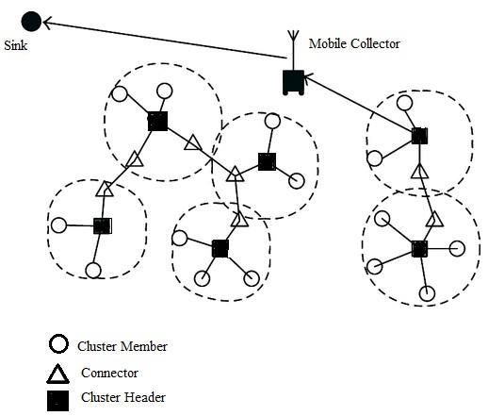

Figure 2.2: System Model

A resource-constrained sensor node *vi* in a distributed WSN will broadcast or transfer data to its cluster header CH*i,j*, it

is more energy efficient and has better communication capabilities Because cluster nodes are not required to be connected to each other in our system, the intercluster connectivity limit is partially lifted.

**Advantages:** This methodology isn’t suitable for applications where data aggregation isn’t permitted.

**Disadvantages:** The model represents a scenario in which nodes execute no data aggregation at all.

## 2.4 In Wireless Sensor Networks, Balanced Clustering for Energy Efficient Routing

**Author:** Dionisis Kandris , Stefanos A. Nikolidakis, Dimitrios D.Vergados and Christos Douligeris, year 2013.

**Methodology:** The Equalized Cluster Head Election Routing Protocol(ECHERP) is an unique protocol proposed in this study that intends to save energy by adopting balanced clustering. Utilizing the Gaussian end approach, ECHERP models the organization as a straight framework and computes the mixes of hubs that can be picked as group heads to expand the organization lifetime.

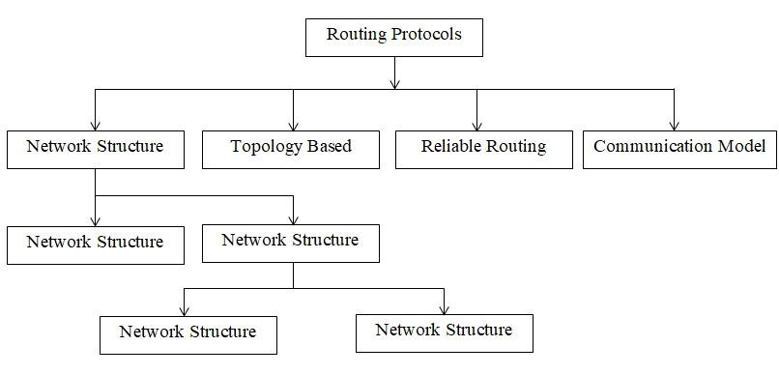

`Figure 2.3: Classification of routing protocols in WSN

**Advantages:** The principal advantage of energy skilled directing in remote sensor networks by means of adjusted grouping is that it performs well in circumstances where recognized properties change quickly.

**Disadvantages:** It’s not a good idea to use it for networks that span big areas.

# Chapter 3 Objectives

Because of their adaptability in solving problems across a wide range of application areas, wireless sensor networks have increased in popularity, and they have the potential to change our lives in a variety of ways. WSNs have shown to be effective in a range of applications.

1. Remote sensor networks are especially helpful in hazardous or distant circumstances, or when various sensors should be put.
2. Node localization techniques are required for area monitoring, medical care monitoring, environmental or earth sensing, industrial monitoring, bushfires detection, landslide detection, war field, and many more applications.

# Chapter 4

# Problem Statement and Methodology

Low result's fast turn of events, minimal expense, serious, multifunctional little remote sensor networks is helped by the quick development of remote correspondence. Since there are a great deal of remote sensor hubs. has been one of the major elements of remote sensor organizations, area experienced project chief in remote sensor networks is a solitary of most significant subjects in remote sensor network examination. We'll tell the best way to involve the limitation technique in one or two situations prior to going over the assessment rules for confined in WSN.

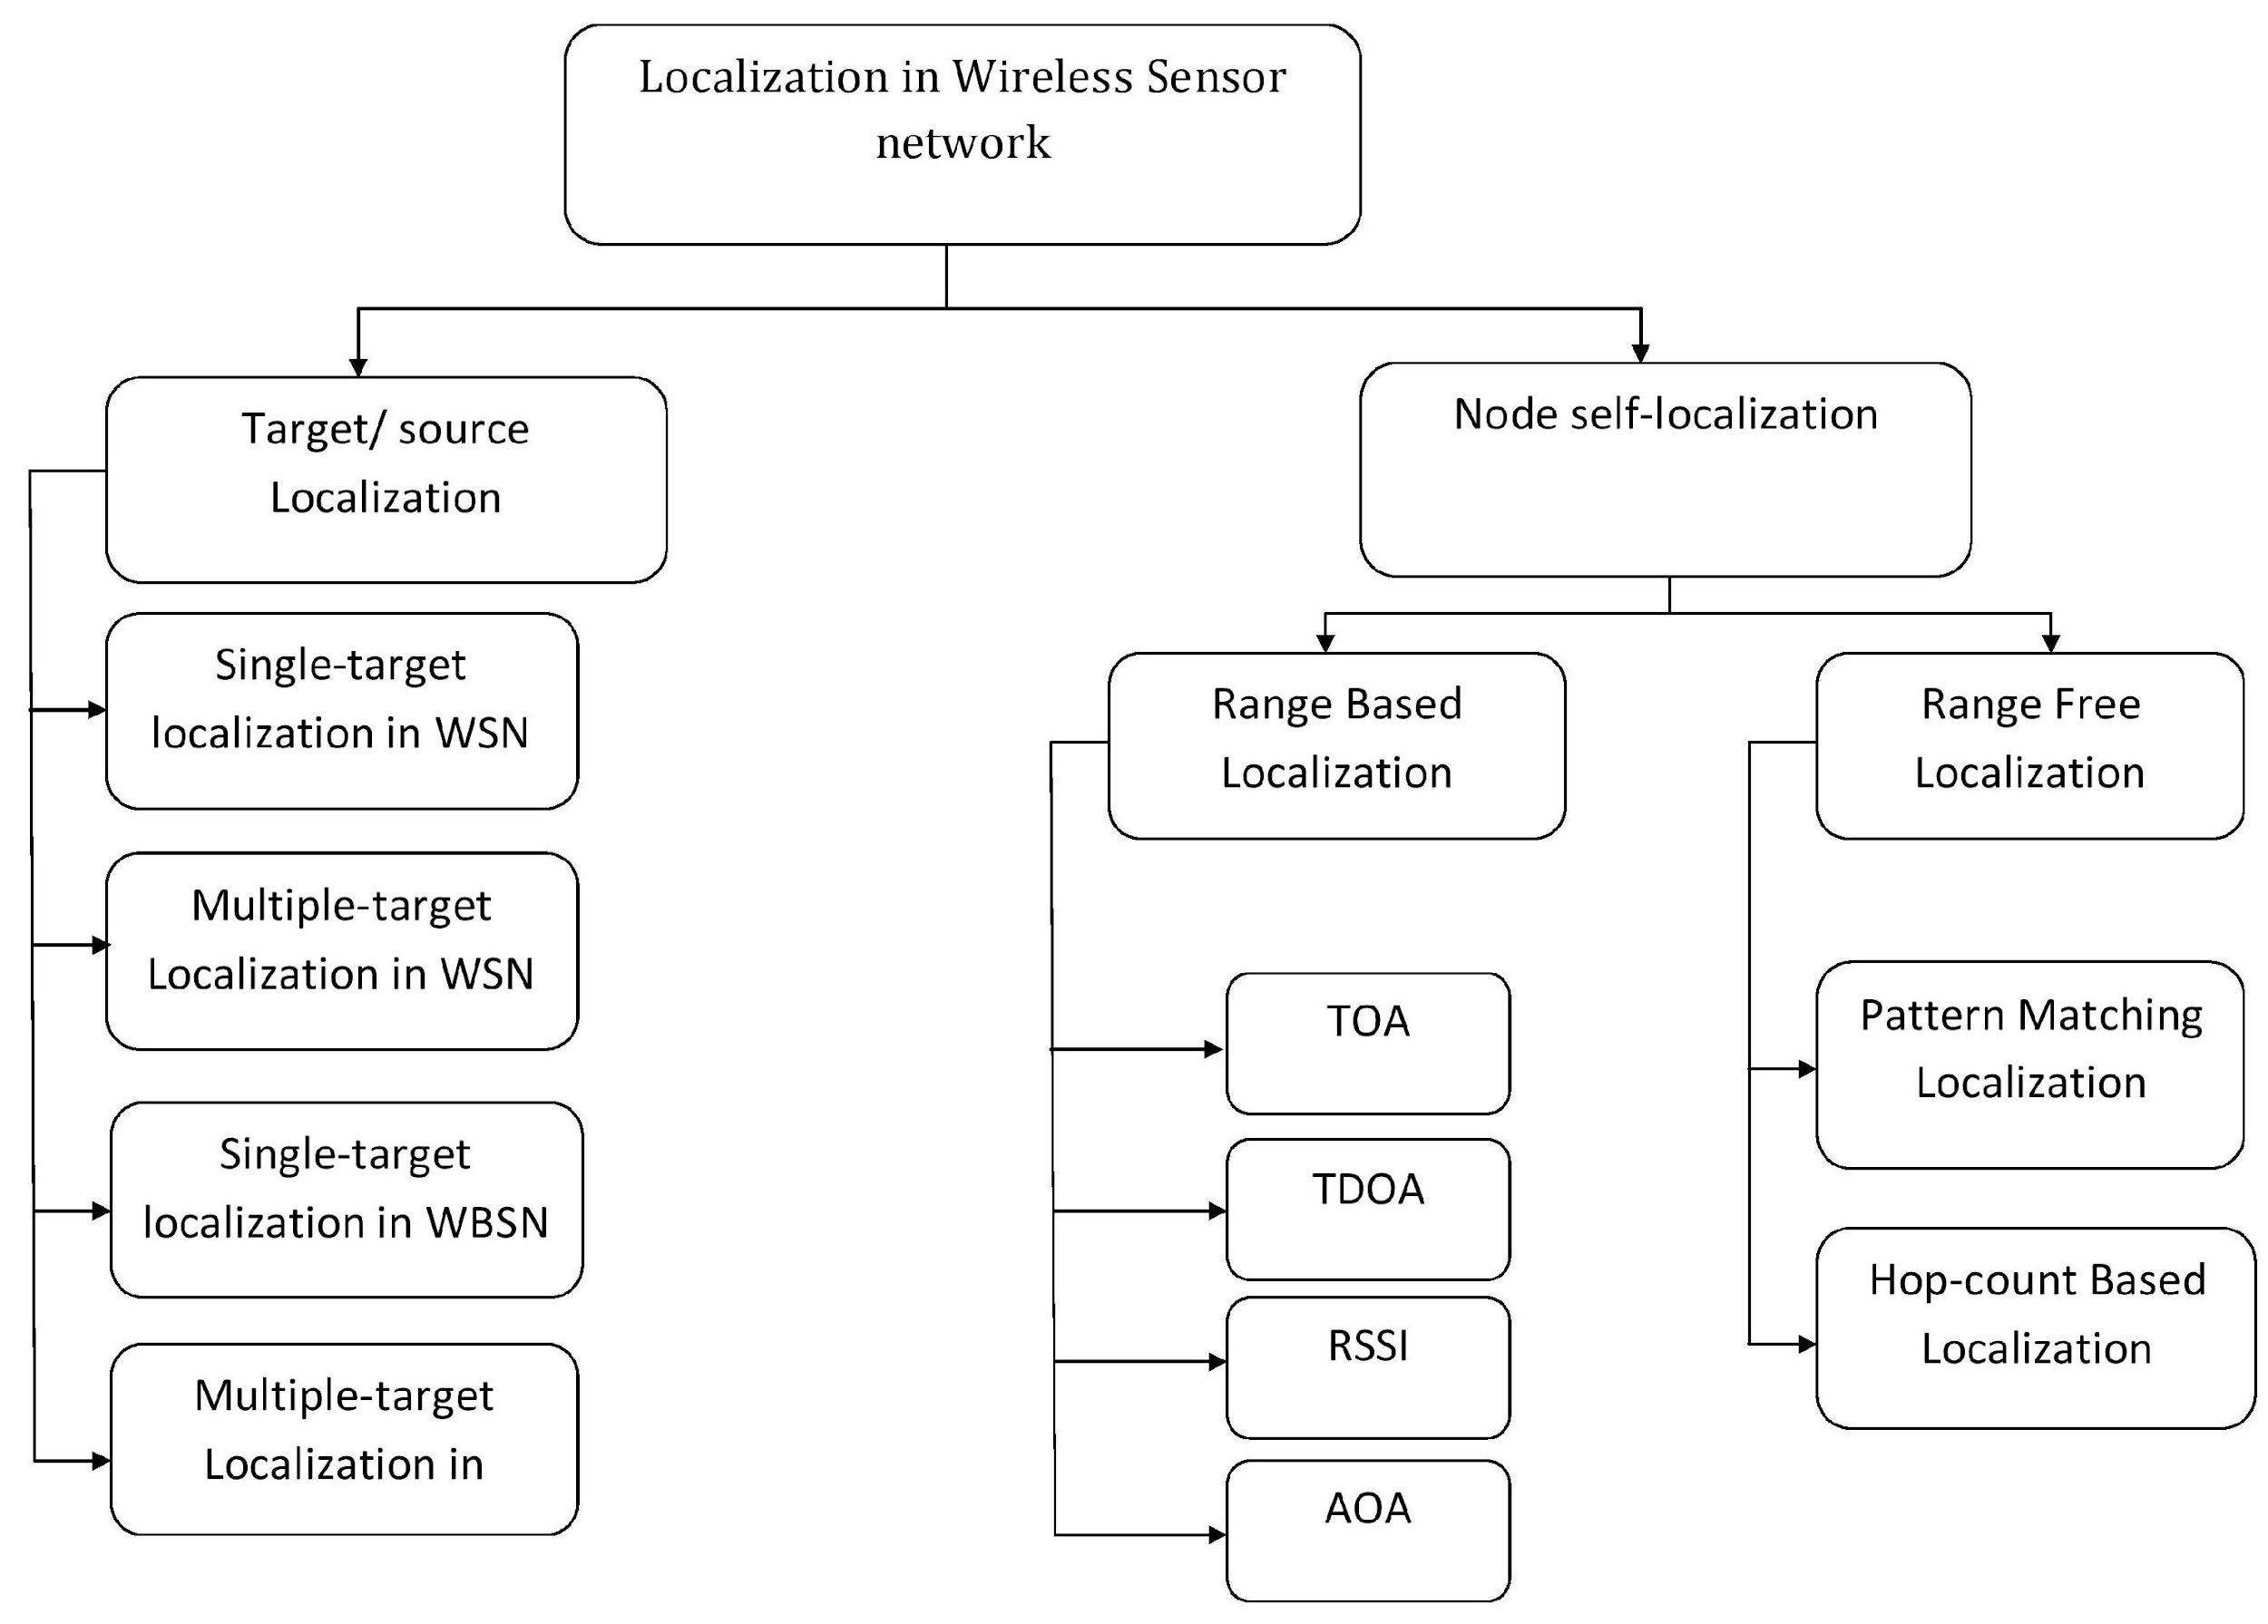

Figure 4.1: Classification-of-localization-algorithms

## 4.1 Localization of the source or the target

**4.1.1 In a wireless sensor network, single-target or source localization is used**

The source localization methods can be used in a variety of situations. Vehicle or aircraft localisation is part of the outdoor application. This system might track human speakers in an indoor setting. Finding tremendous ocean creatures and boats in a submerged environment can be utilized. Energy-based, angle of arrival (AOA), and time difference of arrival are all methods for estimating the source location(TDOA). Energy-based methods are appealing as a lowcost solution since they require less hardware configuration. The energybased source localization is the subject of this survey.

**4.1.2 Localization of Multiple Targets in Wireless Sensor Networks**

Many investigations focus on the location of a single target. However, there are only a few studies that look into multiple-target localization. The most extreme probability assessor is utilized in most of the distributions. The greatest probability assessor's subtleties are as per the following:

During the time stretch t, the got signal strength at ith sensor can be composed as 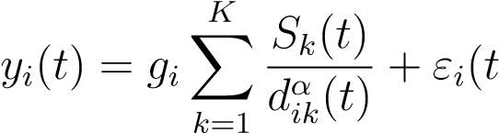) (4.1)

The detachment between the two ith sensor and the kth source is dik(t). There are a total of ten sources. *K*. The gain of the *ith* sensor is represented by ) is a variable at random with a *µi* mean and a *σi*2 variance. The signal energy for the *kth* source is *Sk*(*t*) at a distance of 1 meter. The attenuation exponent is called *α*.

**4.1.3 Limitation of a solitary objective or source in a remote binary sensor organization**

The bulk of source localization approaches rely on signal intensity measurements, implying that the fusion centre is aware of node measurements. The sophisticated mathematical process is required by the node in order to collect the measurements. The methods described above necessitate the transfer of a huge volume of data from sensors, which may be impossible to do due to connectivity restrictions. The double sensors identify signals (infrared, acoustic, light, etc) in their current circumstance and possibly send a sign on the off chance that the strength of the detected sign surpasses a specific limit.

## In an organization of twofold sensors, a couple of articles investigate source restriction. In a remote paired sensor organization, past exploration has endeavored to track down the specific place of a specific source (WBSN).

## 4.2 Node Self-Localization

**4.2.1 Localization with a Range**

|  |  |  |
| --- | --- | --- |
|    (*x*1 − *x*2) (*y*1 − *y*2)   (*x*1 − *x*3) (*y*1 − *y*3)   *A* = 2 ... ...       (*x*1 − *xN*−1) (*y*1 − *yN*−1) |  |  |
|  e*2*2 −*d*e*1*2 − (*x*2 + *y*32) + (*x*21 + *y*12) *d* 2  2 3   *d*e*3* −*d*e*1* − (*x*23 + *y*32) + (*x*21 + *y*12)  *B* =  ...     2 |            |  |
| *d*2 −*d* | |

The most consistent procedures for registering indoor position are time of appearance (TOA), time difference of appearance (TDOA), mark of appearance (AOA), and got signal power (RSS).The TOA method estimates the time it takes for signals to travel between nodes. The TDOA approach finds obscure hubs by assessing the distinction in signal appearance times between anchor hubs and obscure hubs. It can arrive at high running exactness, however it requires extra equipment and uses more energy.

The place of the beacon node was set is h(*x*1*,y*1)*,.....,*(*xN,yN*)*,*i and the unknown node’s position is *X* = [*x,y*]*T*. *d*e*i* is the assessed separation between ith guide hub and obscure hub. The obscure hub's direction grid can be gotten as follows[12]

X = (ATA)−1ATB

e*N*−1 e*1 N*−1 *N*−1 1

**4.2.2 Range-Free Localization**

1. **Design Matching Method:**

Design matching confinement, frequently known as guide based or unique mark calculations, has of late arisen as one of the best reach free restriction draws near. There are two phases to unique mark localisation. The got signals at chosen places are caught in a disconnected data set called radio guide during the main stage. Then, at that point, in the subsequent stage, it works in a web-based mode. By contrasting the ongoing noticed signal properties with the preset qualities on the guide, design matching strategies are used to decide the place of obscure hubs.

1. **Hop-Count-Based Localization:**

DV-Hop is the most widely recognized portrayal of a reach free situating framework. It diminishes equipment necessities by utilizing the typical bounce distance to estimated genuine distances. It’s simple to set up and adapt to a huge network. However, the positional inaccuracy increases in lockstep.

Information broadcast, distance computation, and location estimation are the three stages of the DV-Hop positioning method. The guide hubs send their position data bundle, which incorporates bounce count and is initialised to zero for their neighbors, during the data broadcast stage. Each signal hub's negligible bounce is recorded by the recipient, which disregards the more noteworthy jump for a similar guide hub. Each guide hub uses the accompanying condition to assess the genuine distance of each bounce during the distance estimation stage.

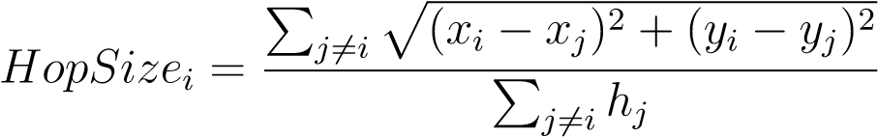 (4.3)

The coordinates of beacon nodes *i* and *j* are (*xi,yi*) and (*xj,yj*) respectively. The typical distance will then be determined and communicated to the organization by anchor. Just the primary normal distance is recorded by obscure hubs, and it is then sent to adjoining hubs. At long last, the obscure hub utilizes Equation4.2 to decide its area. The reexamined technique centers around a few regions to increment restriction precision: normal jump distance between reference point hubs, situation of signal hubs, and hub metadata.

**4.3 This paper researches the DV-Hop Localization Algorithm**

The distance vector directing convention is utilized to carry out the DV-Hop limitation calculation, which is a dispersed rangefree confinement calculation. To decide the distances between guide hubs and obscure hubs, duplicate the normal bounce distance in WSNs by the jump count of the signal hubs. Trilateration, triangulation, and multilateration are then used to accumulate position data for obscure hubs, coming about in localization[14].

**4.3.1 The DV-Hop Algorithm’s Basic Procedure**

The DV-Hop method divides the node localization process into three steps:

**Step 1.** Counting the most un-number of bounces among guide and obscure hubs. Utilizing the traditional distance vector directing framework, guide hubs broadcast data that shows their situations to adjoining hubs. The data contains id,xi,yi,Hi, where id,(xi,yi), and Hi separately show the distinguishing proof, direction, and bounce count of signal hubs I. The worth of Hi is set to zero toward the beginning. The geolocation and bounce counts of guide hubs are recorded as vectors by hubs getting the transmission data, which are then shipped off adjoining hubs (the worth of jump count is augmented by one).

**Step 2.** Attempting to sort out what the typical bounce distance is. The typical bounce distance and least jump include are determined at first to evaluate the distance between obscure hubs and guide hubs. The typical jump distance of entire organizations still up in the air subsequent to getting the restriction and bounce include of signal hubs in the primary stage. The information is accordingly communicated over the whole organization, or across all organizations.

As discussed earlier[9]

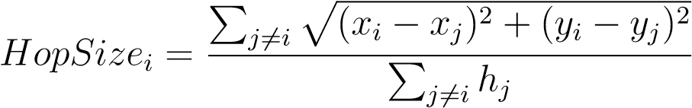 (4.3)

The accompanying recipe is utilized to register the distances between obscure hubs and signal hubs.

*di* = *HopSizei* × *Hop* (4.4)

where *HopSizei* denotes the average hop distance between mobile nodes.

*i* what's more, guide hubs, and Hop means the base jump count between obscure hubs I and reference point hubs.

The green and yellow circles, separately, connote guide hubs and obscure hubs in Figure4.2, which portrays the organization construction of the DVHop confinement method. The lengths and bounce counts between signal hubs L1, L2, and L3 are known, yet A means a hub that is obscure. The typical bounce distance might be assessed utilizing the equation 4.3 as (40 + 75)/(2 + 5) = 16.4m. Obscure hub A gets the typical jump distance from signal hub L2 in 4.2 Network geography. On this premise, the distances between the three reference point hubs L1, L2, and L3 and the obscure hub An are 3 × 16.4m, 2 × 16.4m, and 3 × 16.4m individually, as per formula4.4.

**Step 3.** At the point when the directions and distances among three signal hubs are known, plane calculation can be utilized to appraise the directions of obscure hubs. On the off chance that the directions of three signal hubs are (x1,y1), (x2,y2), and (x3,y3) and the distances between these three reference point centers and a dark center D(x,y) are communicated uninhibitedly as d1,d2 and d3, the going with recipe is gained [12].

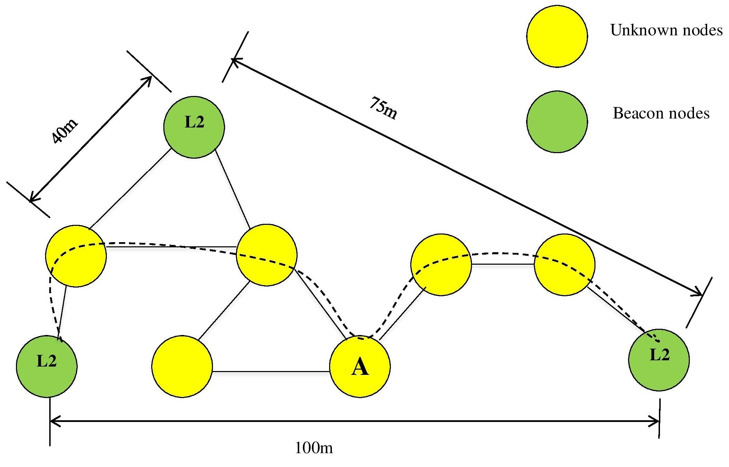

Figure 4.2: Network topology

(*x*1 *x*)

 − 2 + (*y*1 − *y*)2 = *d*21

(*x*2 − *x*)2 + (*y*2 − *y*)2 = *d*22 (4.5)

(*x*3 − *x*)2 + (*y*3 − *y*)2 = *d*23

Meanwhile, the following formula can be used to get the direction of hub D.

This strategy can be utilized to ascertain the directions of obscure hubs. The pathways from reference point hubs to obscure hubs may not be straight in an organization design made by an irregular situation of remote sensor hubs. Subsequently, there are possible a few irregularities in the hub restriction process while utilizing the DV-Hop calculation. Besides, the higher the blemishes, the more bounce counts there are.

**4.3.2 Blunder Analysis of the DV-Hop Algorithm**

The DV-Hop procedure relies upon a structure that spotlights on the briefest way first. WSN ampleness their region information and figure distances to various centers so that reference point center points can show up at various centers with the least skip counts and known positions. In the mean time, to compute the typical jump distance, which is utilized as the normal bounce distance of hub confinement in networks, genuine ways between hubs are thought to be around straight lines, while obscure hubs are supposed to acquire the typical jump distance from the closest reference point hubs with great correspondence conditions to appraise their cognizance positions.

## Thus, various elements in the interpretation cycle can make confinement blunders outperform the genuine necessity. Just a small bunch of these standards exist: network hubs are dispersed unevenly, genuine bounce distances between hubs are far bigger than, or not exactly, the correspondence range, and there are no signal hubs that can be utilized for correspondence close to obscure hubs.

## 4.4 Strategy for Choosing Reliable Anchors

Coming about to getting data from all anchors, the kth anchor becomes mindful of its own situation as well as that of any extra anchors in the affiliation, permitting it to enroll all obvious distances between them. This anchor, obviously, could calculate the studied distance to some other anchor j as well as the related examination goof ek−j considering the utilization of equation1.1.Nonetheless, on the grounds that to the anisotropic geography of the WSN viable, blunder might be over the top in the event that we end up in a circumstance like that displayed in Figure1.3. Subsequently, an ek−j limit is important to guarantee that the jth anchor is dependable corresponding to the kth anchor. ek−j would rise to ek−j assuming the WSN's geography was isotropic.

The roof capability is dxe for this situation. Because of the presence of in the middle among kth and jth secures, a mistake in distance gauge more noteworthy than the right hand side of Equation4.7 emerges provided that the briefest way between them is bended. In this present circumstance, the quantity of bounces between the previous and the last option is essentially bigger than dk−j/R and subsequently we ought to have ought to be utilized all things being equal. Thus, we

picked T1 as a dependable/temperamental limit for secures. At long last, every normal hub will just gauge its distance to the closest anchor and those considered trustworthy by the last option to guarantee a precise distance estimation.

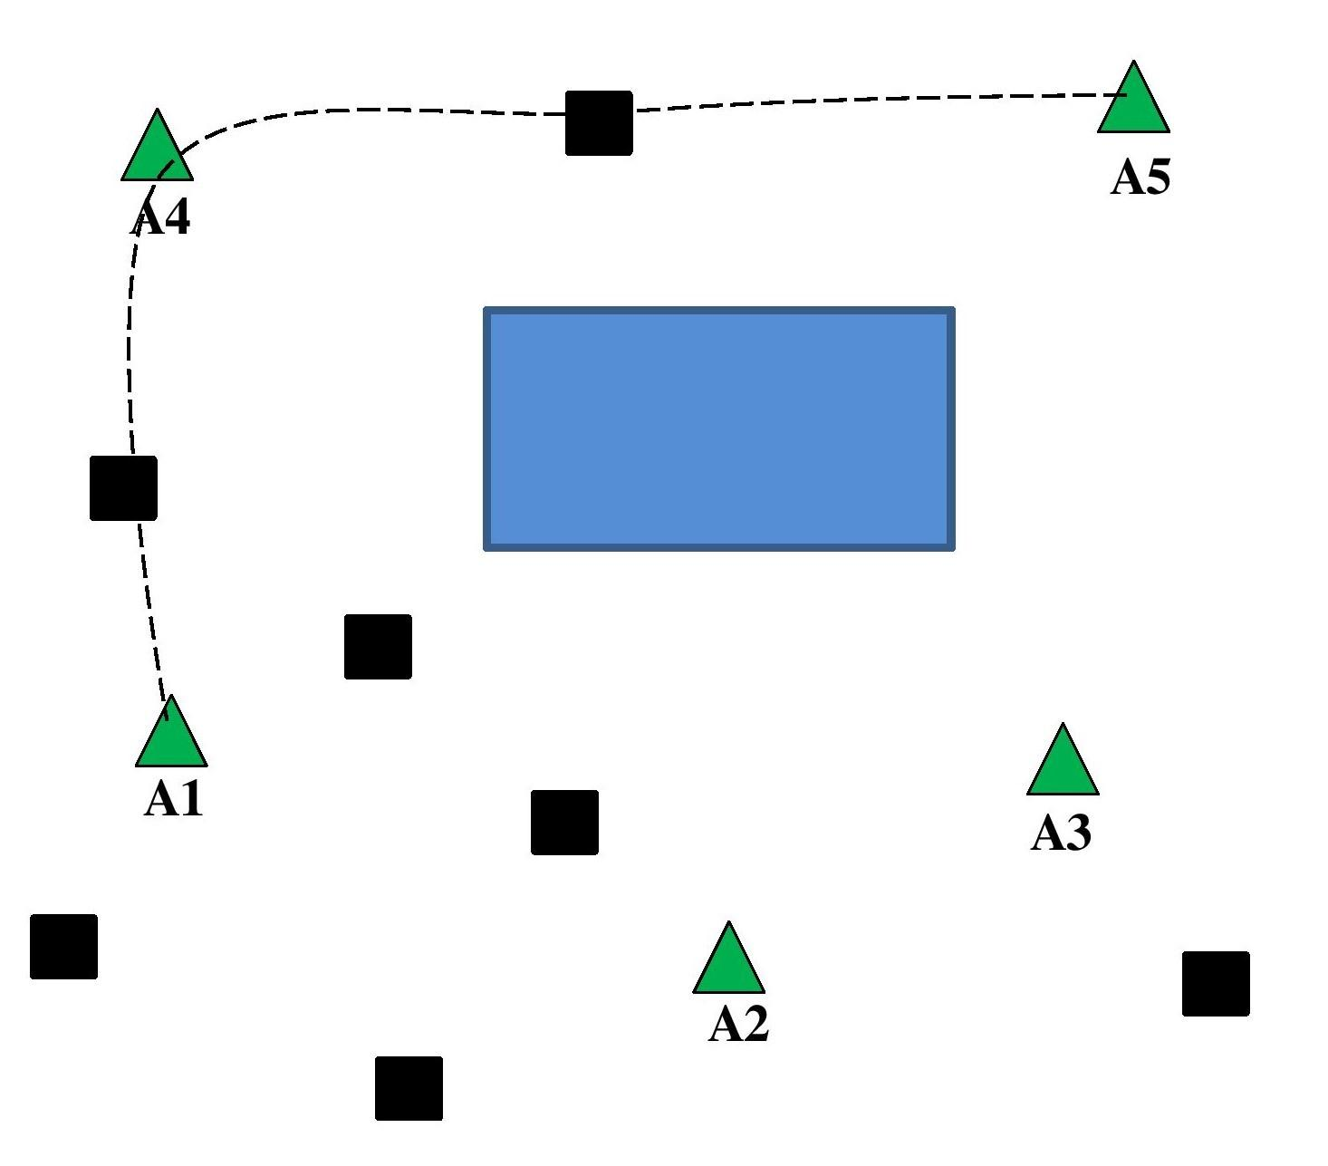

Figure 4.3: Reliable anchors

Be that as it may, on the grounds that, as represented in Figure4.3, the most limited way from the ordinary hub to these anchors might be bended, certain anchors appraised trustworthy by the closest anchor might be administered temperamental by the normal hub. To keep away from this issue, we execute a stricter choice at the ordinary node,√ disposing of any anchor with a bounce count more noteworthy than T2 = d 2S/Re. In the event that the most brief way isn't bended, T2 is the greatest number of jumps that can happen. Limitation calculations 1 and 2 sum up handling stages at anchors and normal hubs, separately, and are recorded.

## 4.5 Algorithm used

**1:** Anchor node localization algorithm

% k insinuates the kth anchor center point % Sk={} for j = 1 to Na and j 6= k do k−j = nk × h¯s k−j = dˆk−j − dk−j

if ek−j ≤ T1,

Sk = Sk ∪{j} end

end

Broadcast a lot of Sk trustworthy anchors.

**2:** Regular node localization algorithm

% I alludes to the ith normal hub %

% The assortment of solid secures at the accompanying anchor center point from the ith conventional center is called Ski. %

% Si is the new course of action of strong anchors at the ith conventional center % Si={}

c = 0

for

if hi−k ≤ T2, Si = Si ∪{k} c = c + 1

end

for j = 1 → c do

ˆji = nji × h¯s end

% ji implies the jth strong anchor center point record in the set Si % %ˆxi and ˆyi can be evaluated by multilateration %.

## 4.6 Distance Estimation Technique

In this paper, we recommend using Equation1.1 to appraise each regularanchor distance. To this point, the typical jump size h¯s between any two sequential hubs on the most limited way between any ordinary and anchor hubs ought to be exactly determined. We should begin by alluding to the irregular factors that depict the distance between any two hubs as Z. To show up to an end.

h¯s = E{Z} (4.8)

We start by working out Z's aggregate dissemination capability, which is characterized as

FZ(z) = P(Z ≤ z) (4.9)

where z is the arbitrary variable Z understood. Since Z ≤ z is ensured provided that there are no hubs in the ran region F, as per Figurere4.4, we get

FZ(z) = P(F0) (4.10)

where P(F0) is the opportunity that the occasion F0 = no hubs in the ran region F occurs. The likelihood of having K hubs in F follows a Binomial conveyance Bin(N,p), where, on the grounds that the hubs are consistently dispersed in S. Bin(N,p) might be effectively approximated by a Poisson dispersion with λ = N/S being the hubs thickness in the organization for a generally large N and little p. The possibility having K sensors in F can consequently be determined as follows:

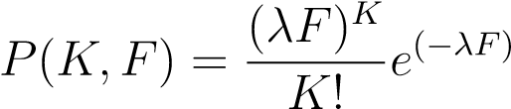 (4.11)

Equation4.11 is injected into Equation4.10 and *K* is replaced by 0, resulting in

*FZ*(*z*) = *e*(−*λF*) (4.12)

It is simple to demonstrate that using some geometrical characteristics and trigonometric operations.

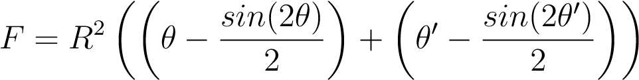 (4.13)

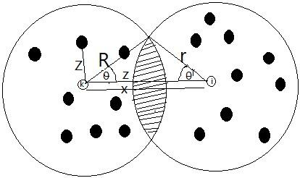

Figure 4.4: Distance analysis

# Chapter 5

# Simulation and Analysis of the Results

## 5.1 Creating an Environment for Network Simulation

Evaluate the usefulness and applicability of the new technique provided here, run system-level simulations utilising MATLAB software, and compare and contrast test results. The different wireless sensor nodes, including 8,6,4,2 anchor nodes and 100,200,300 and 400 unknown nodes.

## 5.2 Simulation and Analysis of Performance

In the accompanying tables, the red and dark + signify Mobile genuine hub and Mobile gauge area, separately, while the green lined blue means Anchor hubs. The result of the least jump and the typical bounce distance between the two hubs is utilized to appraise distance between obscure hubs and guide hubs; notwithstanding, the base number of bounces between hubs is for the most part represented by the correspondence span. These simulations are used to compare the proposed method against the absolute best delegate confinement techniques right now accessible in the writing, for example, DV-Hop and Original, utilizing the indistinguishable organization conditions. We suggest utilizing the standardized root mean square blunder (NRMSE) as an assessment criterion, which is defined as follows:

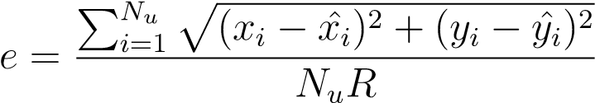 (5.1)

## 5.3 Simulation and testing parameter

1. **Constant Anchor or Beacon node with Varying Mo-bile or Unknown node**(shown in figure5.1a, 5.1b, 5.1c and 5.1d)

|  |  |  |
| --- | --- | --- |
| **Number of Beacon or Anchor nodes** | **Number of Mobile or Unknown nodes** | **Area in squared meter** |
| 04 | 100 | 100 |
| 04 | 200 | 100 |
| 04 | 300 | 100 |
| 04 | 400 | 100 |

1. **Constant Mobile or Unknown node with Varying**

**Anchor or Beacon node**(shown in figure5.2a, 5.2b, 5.2c and

5.2d)

|  |  |  |
| --- | --- | --- |
| **Number of Beacon or Anchor nodes** | **Number of Mobile or Unknown nodes** | **Area in squared meter** |
| 02 | 100 | 100 |
| 04 | 100 | 100 |
| 06 | 100 | 100 |
| 08 | 100 | 100 |

1. The positioning NRMSE accomplished by proposed DV-Hop and RAL(real) for various unknown nodes with constant anchor nodes is shown in

Figure5.3a.

1. The planned DV-Hop accomplished the NRMSE and RAL(real) for different anchor nodes with a constant unknown node is shown in Figure5.3b.

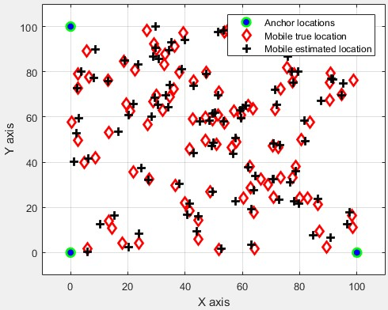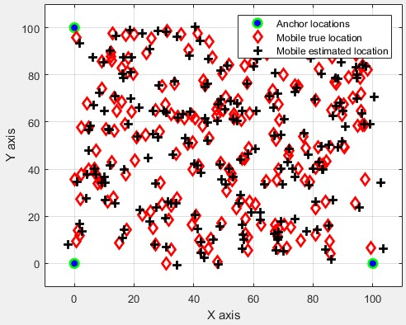

(a) Anchor nodes:04, Unknown node:100 (b) Anchor nodes:04, Unknown node:200

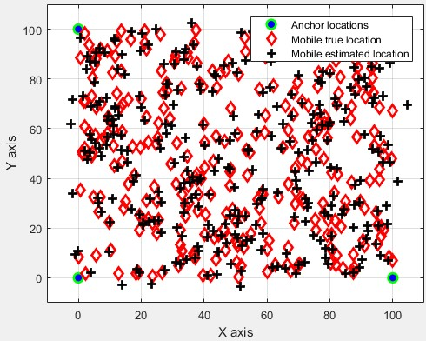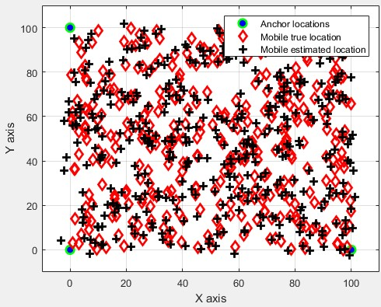

(c) Anchor nodes:04, Unknown node:300 (d) Anchor nodes:04, Unknown node:400

Figure 5.1: Constant Anchor or Beacon node with Varying Mobile or Unknown node

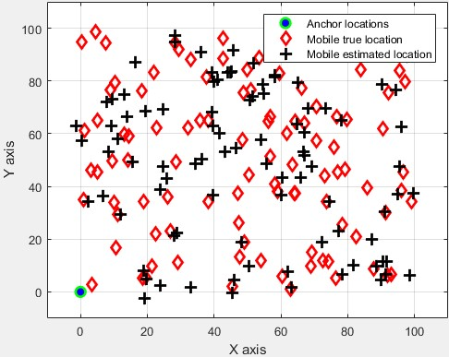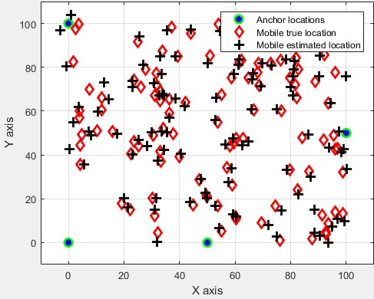

(a) Anchor nodes:02, Unknown node:100 (b) Anchor nodes:04, Unknown node:100

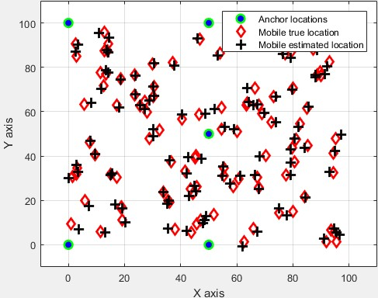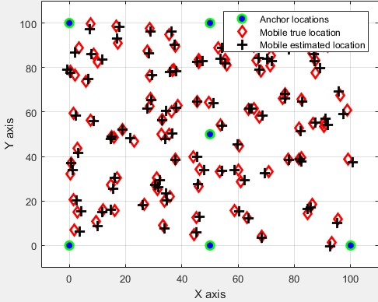

(c) Anchor nodes:06, Unknown node:100 (d) Anchor nodes:08, Unknown node:100

Figure 5.2: Constant Mobile or Unknown node with Varying Anchor or Beacon node

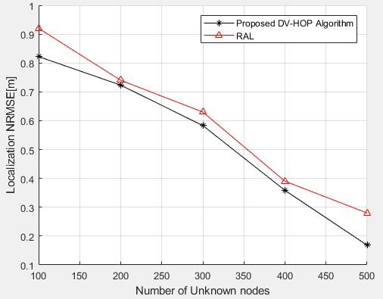

1. Number of Unknown node vs Localization NRMSE

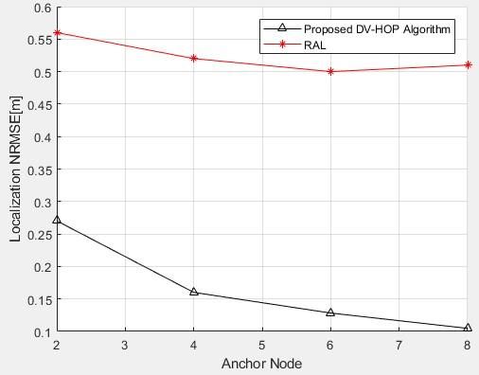

1. Number of Anchor node vs Localization NRMSE

Figure 5.3: Error measurement by Localization NRMSE

# Chapter 6

# Conclusion and Future Work

## 6.1 Conclusion

## Since the DV-Hop procedure has issues in WSNs, like lopsided hub dissemination, openings, and critical errors in the normal jump distance, another limitation technique was suggested that consolidates the DV-Hop strategy with a centroid of half-measure weighted. Signal hubs utilize the centroid calculation to decide their area, and afterward use the restricted exactness as the load for finding obscure hubs. The confinement calculation for AWSNs is concocted in this paper, with every customary hub only assessing its distances to valid anchors

## 6.2 Future work

1. Based on enhancements and modifications to the original DV-Hop localization method, we may enhance efficiency by adding additional functions, resulting in a better performance with fewer anchor nodes.
2. The effectiveness of hybrid DV-Hop algorithms for localization (iDVHop1, iDV-Hop2, and Quad DV-Hop) can also be improved.

# References

1. S. Chatterjea and P. Havinga, “A dynamic data aggregation schemefor wireless sensor networks,” Proc Program for Research on Integrated Systems and Circ its, vol. 41, no. 2, pp. 116–125, 2017.
2. B. Rashid and M. H. Rehmani, “Applications of wireless sensor networks for urban areas: a survey,” of Networkand Computer Applications, vol. 60, pp. 1 192–219, 2016.
3. M. Mehrabi, H. Taheri, and P. Taghdiri, “An improved DVhop localization algorithm based on evolutionary algorithms,” Telecommunication Systems, vol. 64, no. 4, pp. 639–647, 2017.
4. D. Nicolescu and B. Nath, Ad-HOC Positioning System, Proceedingsof IEEE GlobeCom, November 2003.
5. D.Culler, D.Estrin and M.Strivastava, Overview of Sensor Networks,IEEE Computer Society, 2009.
6. K. Whitehouse The design of Calamari: an ad-hoc localization systemfor sensor networks, Master’s Thesis, UC Berkeley, 2012.
7. ScatterWeb, http://www.scatterweb.net/, 2005
8. X. Yang and W. Zhang, “An improved DV-hop localization algorithmbased on hop distance and hops correction,” International Journal of Multimedia and Ubiquitous Engineering, vol. 11, no. 6, pp. 319–328, 2016.
9. L. Cui, C. Xu, G. Li et al., “A high accurate localization algorithmwith DV-hop and differential evolution for wireless sensor network,” Applied Soft Computing, vol. 68, 2018.
10. M. M. Ren, Z. J. Xie, G. Jin et al., “DV-hop localization algorithmbased on multi-mobile beacon,” Computer Engineering, vol. 40, no. 10, pp. 92–97, 2014.
11. X. L. Cui, W. B. Chen, and C. Hao, “Research on DV-HOP algorithmfor wireless sensor networks,” in Proceedings of International Conference on Knowledge Management in Organizations, Beijing, China, August 2017.
12. D.Niculescu and B.Nath Error Characteristics of Ad Hoc PositionningSystems (APS), MobiHoc’04, May 2004.
13. T. Wang, X. Wei, J. Fan, and T. Liang, “Adaptive jammer localizationin wireless networks,” Computer Networks, vol. 141, pp. 17–30, 2018.
14. K.-Y. Kim and Y. Shin, “A distance boundary with virtual nodes for the weighted centroid localization algorithm,” Sensors, vol. 18, no. 4, p. 1054, 2018.
15. A New Distance Vector-Hop Localization Algorithm Based on Half Measure Weighted Centroid, Published 3 January 2019.

